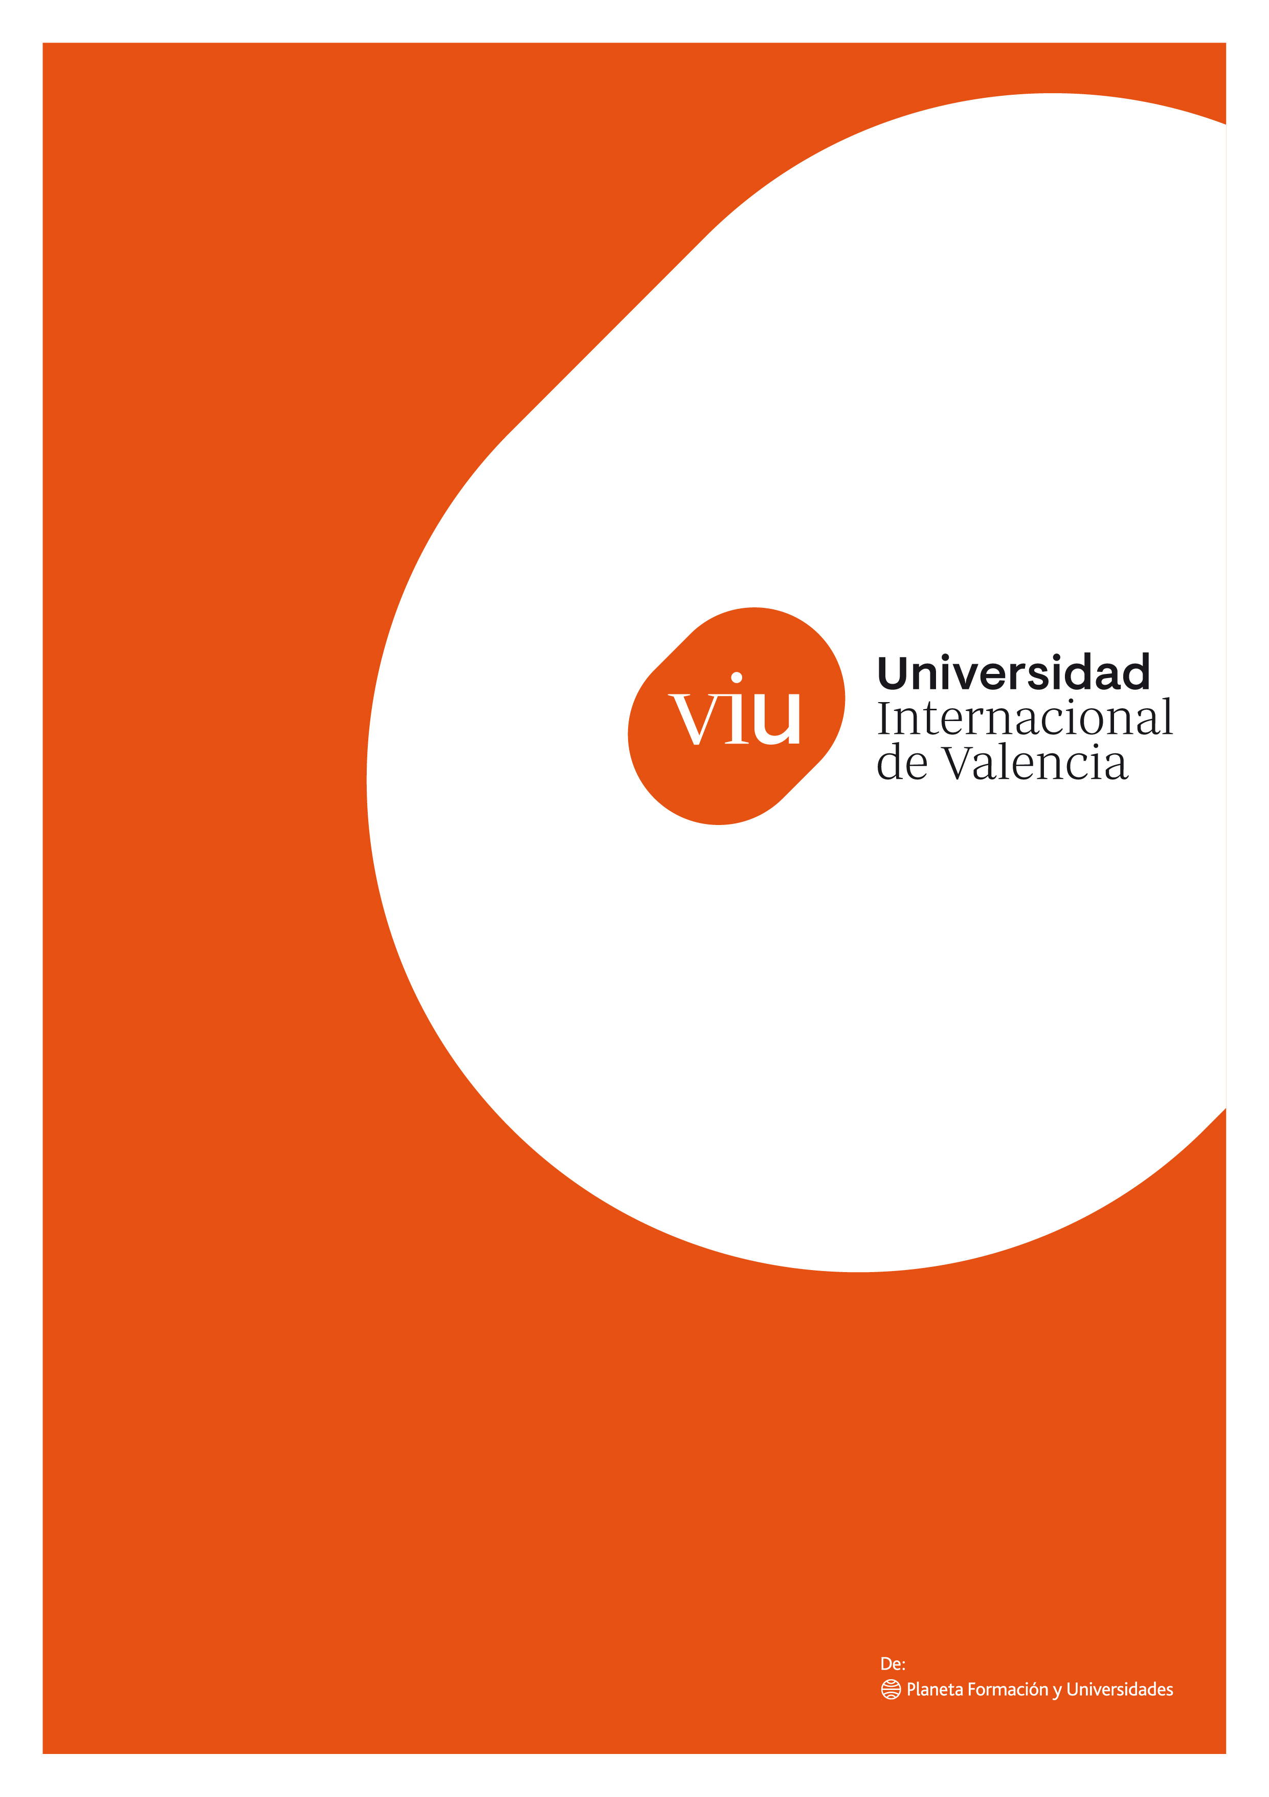

WaterChain: Blockchain-Powered Water Access for Underserved Communities

Submitted by | Miguel Angel Gagliardo
Institution | Valentian International University
Date | May 5th 2025
Funding Requested | USD 500,000
Executive Summary

WaterChain is an innovative blockchain-based initiative aimed at addressing the global water crisis by providing a transparent, decentralized, and secure system for tracking and distributing water resources in underserved communities. By leveraging blockchain technology and satellite internet, the project ensures the efficient use of resources, combats corruption in water aid distribution, and empowers local communities with tools to manage water access sustainably.

The pilot project is set to be launched in two water-scarce rural regions across Sub-Saharan Africa in Nigeria, directly benefiting over 10,000 residents. The requested funding will cover smart contract development, infrastructure deployment, local training, monitoring systems and sustainability mechanisms.

Introduction

Globally, over 2.2 billion people lack access to safely managed drinking water¹. In many cases aid and resources intended to improve water infrastructure are lost due to inefficiencies, lack of transparency or corruption.

The blockchain technology² offers a novel opportunity to redesign water aid systems with transparency, accountability and community control at the core.
WaterChain emerges as a response to this pressing issue. It proposes a blockchain-powered water aid management and monitoring system that tracks water deliveries, infrastructure repairs, and financial flows in real-time, empowering stakeholders, increasing donor trust and improving access to this essential resource.

Objectives

The General Objective is to develop and deploy a blockchain-based system that improves access to clean water in underserved communities through transparency, accountability, and participatory governance. Stakeholders - including donors, NGOs, and socially responsible investors - will be able to contribute to this non-profit initiative through a tokenized investment model³.
Each contribution will be represented by a utility token that ensures transparent tracking of fund usage and grants investors access to non-monetary premiums such as governance rights, impact certificates (proof of social impact) or priority access to future project reports and involvement. This model incentivizes engagement whilst ensuring all resources are directed toward improving water access and infrastructure in African communities.

The Specific Objectives are:
- Design and implement a smart contract system⁴ to track water distribution and infrastructure maintenance as well as the WaterChain platform.
- Deploy water collection and purification units integrated with IoT⁵ sensors and blockchain nodes.
- Train local stakeholders to operate and manage the WaterChain platform.
- Monitor and evaluate the system’s impact over a 12-month pilot period.

Methodology

The project will be carried out in four main phases:
- Design and Development (Months 1–3):
  - Develop a custom blockchain network (or use an existing permissioned blockchain like Hyperledger Fabric⁶).
  - Design smart contracts for tracking water delivery, usage, and maintenance.
  - Integrate IoT devices to collect real-time water usage and quality data.
  - Design and develop the WaterChain platform.
- Infrastructure Deployment (Months 4–6):
  - Identify and partner with local NGOs and governments.
  - Deploy satellite internet connetivity required for the blockchain and IoT nodes.
  - Install solar-powered water filtration systems equipped with IoT sensors.
  - Establish local blockchain nodes.
  - Create and distribute all tokens to stakeholders and initial platform investors.
- Capacity Building (Months 7–9):
  - Conduct workshops for local technicians and community leaders.
  - Provide digital wallets for water credit management and introduce mobile-based interfaces for users.
- Monitoring & Evaluation (Months 10–12):
  - Collect and analyze usage data.
  - Adjust smart contract logic based on community feedback.
  - Produce a public impact report and technical whitepaper.

Work Plan / Timeline

Phase | Timeline | Key Deliverables
Design & Development | Months 1-3 | Blockchain System + Smart Contracts
Infrastructure Deployment | Months 4-6 | Hardware Setup, IoT Integration
Capacity Building | Months 7-9 | Training sessions, Onboarding
Monitoring & Evaluation | Months 10-12 | Impact report, final adjustments

Budget Summary

Category | Estimated Cost (USD)
Blockchain Development | $120,000
IoT Hardware & Water Units | $150,000
Training & Capacity Building | $50,000
Monitoring & Evaluation | $30,000
Project Management & Personnel | $80,000
Travel & Local Logistics | $20,000
Contingency (10%) | $50,000
Total | $500,000

Expected outcomes and Impact
WaterChain aims to create measurable, real-world change through the following results:
- Direct Access to Clean Water: Over 10,000 residents in Nigerian agricultural communities will gain access to reliable, safe, and efficiently distributed water through the initial pilot deployment.
- Digital Traceability of Resources: Every step of the water aid lifecycle - from donation to distribution - will be trackable and verifiable on the deployed blockchain, fostering transparency and efficiency.
- Empowered Participation: Community members will have a direct voice in how water resources are managed, via decentralized autonomous organization⁷ voting systems that reflect their needs and priorities.
- Tangible Rewards for Social Investors: Supporters will receive digital proof of impact (e.g. NFTs⁸ and certificates) tied to the real-world benefits their contributions have enabled, creating a new paradigm of socially conscious investing.
- Blueprint for Expansion: The pilot will serve as a tested prototype, ready to be replicated in similar regions across Africa where water insecurity persists.
- Enhanced Credibility and Access to Capital: With every transaction and outcome recorded on the blockchain, the platform will generate accountability, unlocking trust from major funders, institutions, and social impact organizations.

Sustainability

WaterChain’s design embeds long-term viability through technology, community involvement, and a hybrid funding structure:
- Token-Driven Engagement: Utility tokens incentivize continued involvement from backers allowing them to participate in governance, receive recognition and remain committed to the project’s mission over time.
- Decentralized Community Governance: Decision-making is distributed among stakeholders allowing for self-determined, relevant solutions that evolve with community needs rather than external directives.
- On-Chain Financial Integrity: All inflows and expenditures are recorded on a tamper-proof ledger, ensuring fiscal responsibility and allowing funders to audit projects independently.
- Open Access and Modularity: Given the platform is open-source licensed it enables easy replication, adaptation, and integration into national or NGO-led initiatives without proprietary barriers.
- Strategic, Cross-Sector Partnerships: By aligning with governments, water NGOs, and development institutions, WaterChain builds a resilient ecosystem to support long-term scaling, maintenance, and funding continuity.

References

- UNICEF. (2023). Drinking water, sanitation and hygiene (WASH) estimates. https://data.unicef.org/topic/water-and-sanitation/drinking-water/
- NIST. (2021). Blockchain.
https://www.nist.gov/blockchain
- Forbes. (2024). Fund Tokenization: How Close To The Next Financial Revolution?
https://www.forbes.com/sites/digital-assets/2024/11/03/fund-tokenization-how-close-to-the-next-financial-revolution/
- IBM. (2021). What are smart contracts on blockchain? https://www.ibm.com/think/topics/smart-contracts
- IBM. (2023). What is the Internet of Things (IoT)?
https://www.ibm.com/think/topics/internet-of-things
- Linux Foundation Decentralized Trust. (2023). Hyperledger Fabric.
https://www.lfdecentralizedtrust.org/projects/fabric
- The Ethereum Foundation. (2022). What are DAOs?
https://ethereum.org/en/dao/
- Blockchain Council. (2025). What is an NFT?
https://www.blockchain-council.org/nft/nft-guide-everything-you-need-to-know/

